Productivity Application

Sprint 1 Ending Apr 12th, 2023

Context
First Day of Sprint 1: Mar 28th, 2023
Last Day of Sprint 1: Apr 12th, 2023
Working Days in Sprint 1: 15

Team Members
The following cross-functionality team members participated in the sprint. Also listed are the days they were expected to work and the number of days they did work.
Name | Role in the Sprint | Planned Days | Worked Days
Seethal Kavumnkal | Developer | 15 | 14
Vaishakh Nambiar | Developer | 15 | 14
Veeksha Suresh | Developer | 15 | 13
Vignesh G S | Product  Owner | 15 | 13
Utkarsh Dev | Scrum Master | 15 | 15

Sprint 1 and Sprint 2 Sprint 1 and Sprint 2
Internal Assessor Product Owner

User Stories

User Story ID | As a <type of user> | I want to <perform some task> | so that I can <achieve some goal>
1 | Scrum Master | Facilitate Daily Scrum meets | Ensure the project stays on track.
2 | Employee | Be reminded of upcoming deadlines | Complete my tasks on time.
3 | Prdu | See the big picture view of department work | Stay in the loop.
4 | Scrum Master | Ensure the progress on the project is going smoothly | Consistent progress is taking place on the project
5 | Developer | Follow the requirements of the owner | Create the desired end product
6 | Developer | Keep up with the schedule made by the scrum master | Consistently progress the development of the project
7 | Scrum Master | Keep a record of progress made | Keep track of the project’s development as it progressess

Product Backlogs
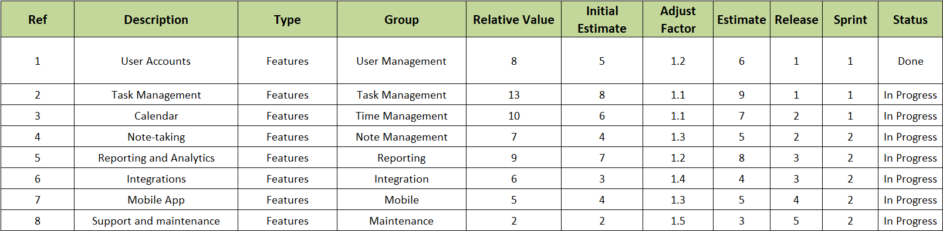

Iteration Planning
Iteration Planning with the Product Owner
- Introduction: Review the purpose of the iteration
- Vision and Roadmap: Discuss the overall product vision
- Number of user stories fit: Choose 6 user stories for the iteration
- Current Status: Review the completed user stories from the previous iteration
- Iteration Theme / Name: Named the iteration "Dashboard Update"
- Prior Data: Review feedback from customer surveys
- Dates: Iteration will start on April 24th and end on May 14th
- Capacity: Team capacity is estimated to be 60 hours per person
- Issues / Logistics: Discuss the need to purchase additional software licenses
- DOD: Review the Definition of Done for the iteration
- Backlog Extract: User stories extracted from the product backlog include:
      - As a user, I want to be able to customize the color scheme of my dashboard
      - As a user, I want to be able to assign a priority level to tasks
      - As a user, I want to be able to add tags to tasks for easy organization
      - As a user, I want to be able to view a summary of my weekly productivity
      - As a user, I want to be able to set reminders for upcoming tasks
      - As a user, I want to be able to export my productivity data as a CSV file
- Tasking: User stories broken down into tasks and estimated time required:
    - Customize dashboard color scheme (12 hours)
    - Add priority level feature (16 hours)
    - Add tags feature (16 hours)
    - Weekly productivity summary feature (24 hours)
    - Set reminders feature (20 hours)
    - Export data as CSV feature (16 hours)
- Issues and Risks: Identified risks include potential conflicts in scheduling due to upcoming holidays
- Dependencies and Assumptions: Assumed that software licenses will be purchased in a timely manner
- "Commitment": Team is committed to completing all user stories and tasks within the iteration
- Actions: Actions include scheduling team meetings, purchasing software licenses, and assigning tasks to team members
- Retrospect: Plan to hold a retrospective at the end of the iteration to review progress and identify areas for improvement
Total 80 hours

Daily Scrum Report
The meeting usually takes about 15 minutes and happens at the start of the day. Participants are Scrum Master, the Scrum Team and Product Owner. The Scrum Master takes charge of the meeting. Each member of the Scrum Team is expected to answer three questions:
“What I did yesterday, what I will do today, what impedes me”
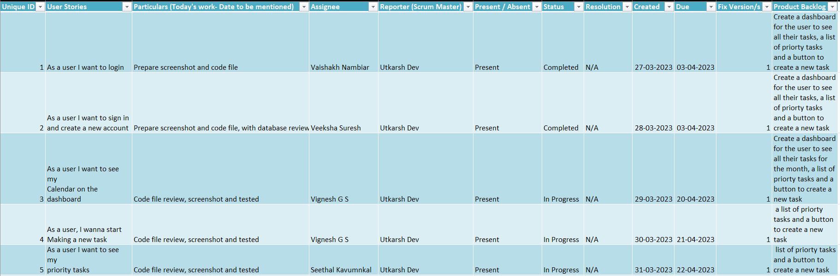
The Scrum Master wants to know what tasks are "done" and whether tasks in progress will complete as expected.

Test Cases for <Sprint 1>
Project Name: Productivity Application
Test Case 1
Test Case ID: PA_01 |  |  |  | Test Designed by: Veeksha Suresh, Utkarsh Dev
Test Priority (Low/Medium/High): Med |  |  |  | Test Designed date: 03/04/23
Module Name: Login screen |  |  |  | Test Executed by: Vaishakh Nambiar
Test Title: Verify login with valid username and password |  |  |  | Test Execution date: 07/04/23
Description: Test the login page functionality
Pre-conditions: User has valid username and password present in the database
Dependencies:
Step | Test Steps | Test Data | Expected Result |  | Actual Result | Status (Pass/Fail) | Notes
1 | Navigate to login page |  | User should be able to navigate to the login page and login using their credentials |  | User able to navigate and login to the system | Pass | Notes
2 | Provide valid username | Username: |  |  | User able to navigate and login to the system | Pass
3 | Provide valid password | Password: |  |  | User able to navigate and login to the system | Pass
4 | Click on Login button |  |  |  | User able to navigate and login to the system | Pass
Post –Conditions:
User is validated with database and successfully logins to account. The account session details are logged in database.

Project Name: Productivity Application
Test Case 2
Test Case ID: PA_02 |  |  |  | Test Designed by: Vignesh GS
Test Priority (Low/Medium/High): Med |  |  |  | Test Designed date: 09/04/23
Module Name: Dashboard |  |  |  | Test Executed by: Seethal Kavumnkal
Test Title: Verify dashboard after user login |  |  |  | Test Execution date: 13/04/23
Description: Test the Dashboard after user logs in to his/her account
Pre-conditions: User has valid username and password present in the database and has his/her associated data present.
Dependencies:
Step | Test Steps | Test Data | Expected Result |  | Actual Result | Status (Pass/Fail) | Notes
1 | Navigate to login page |  | User should be able to navigate to the login page and login using their credentials |  | User able to navigate and login to the system | Pass | Notes
2 | Provide valid username | Username: |  |  | User able to navigate and login to the system | Pass
3 | Provide valid password | Password: |  |  | User able to navigate and login to the system | Pass
4 | Click on Login button |  |  |  | User able to navigate and login to the system | Pass
5. | View user-data present in the Database |  | User should be able to view their data which present in the database |  | User data fetched and displayed from database | Pass
Post –Conditions:
User is validated with database and successfully logins to account. The account session details are logged in database. User-data fetched and displayed.

Contents and Assessment
Points Planned: 7
Points Earned: 3
Story | Points | Result
Story 1 | 1 | Finished
Story 2 | 1 | Finished
Story 3 | 1 | Finished
Story 4 | 2 | In progress
Story 5 | 2 | Not Finished

Sprint 1 Implementation
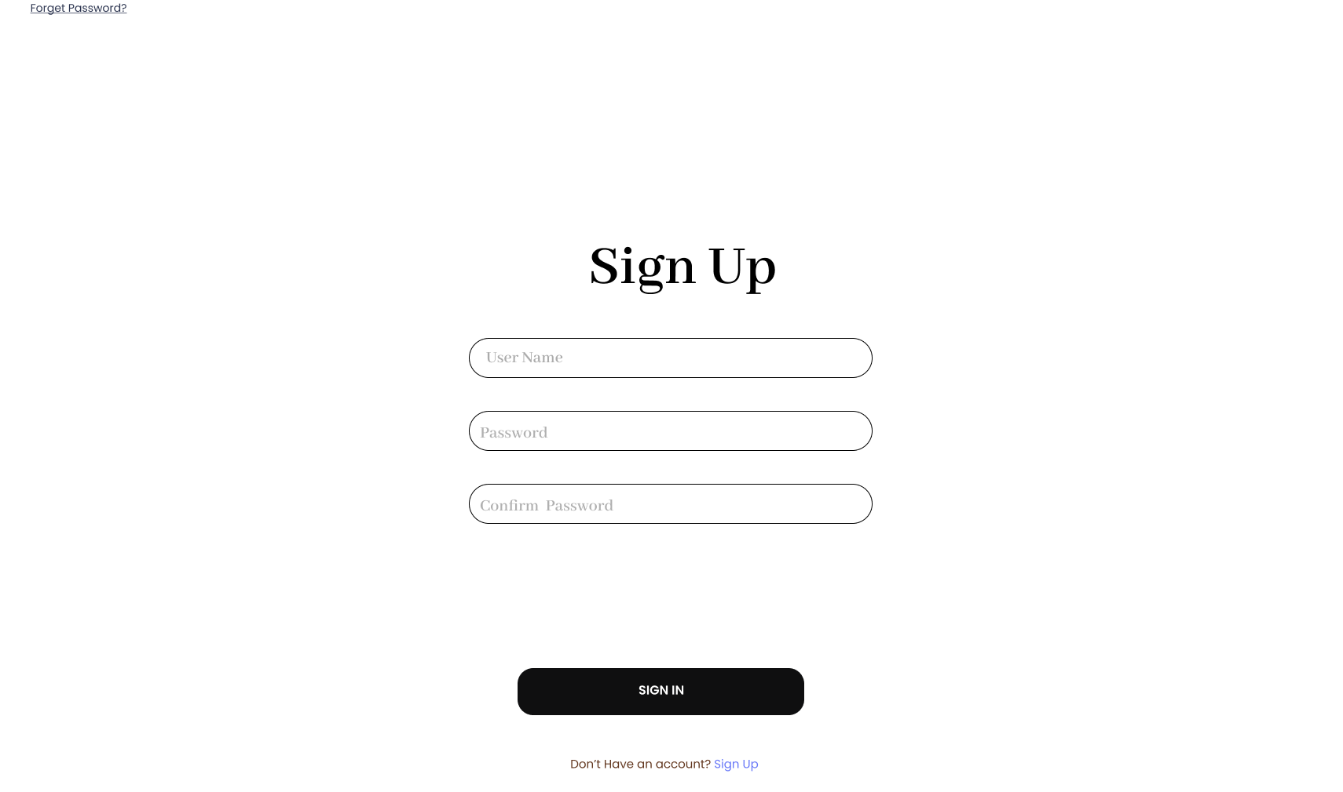

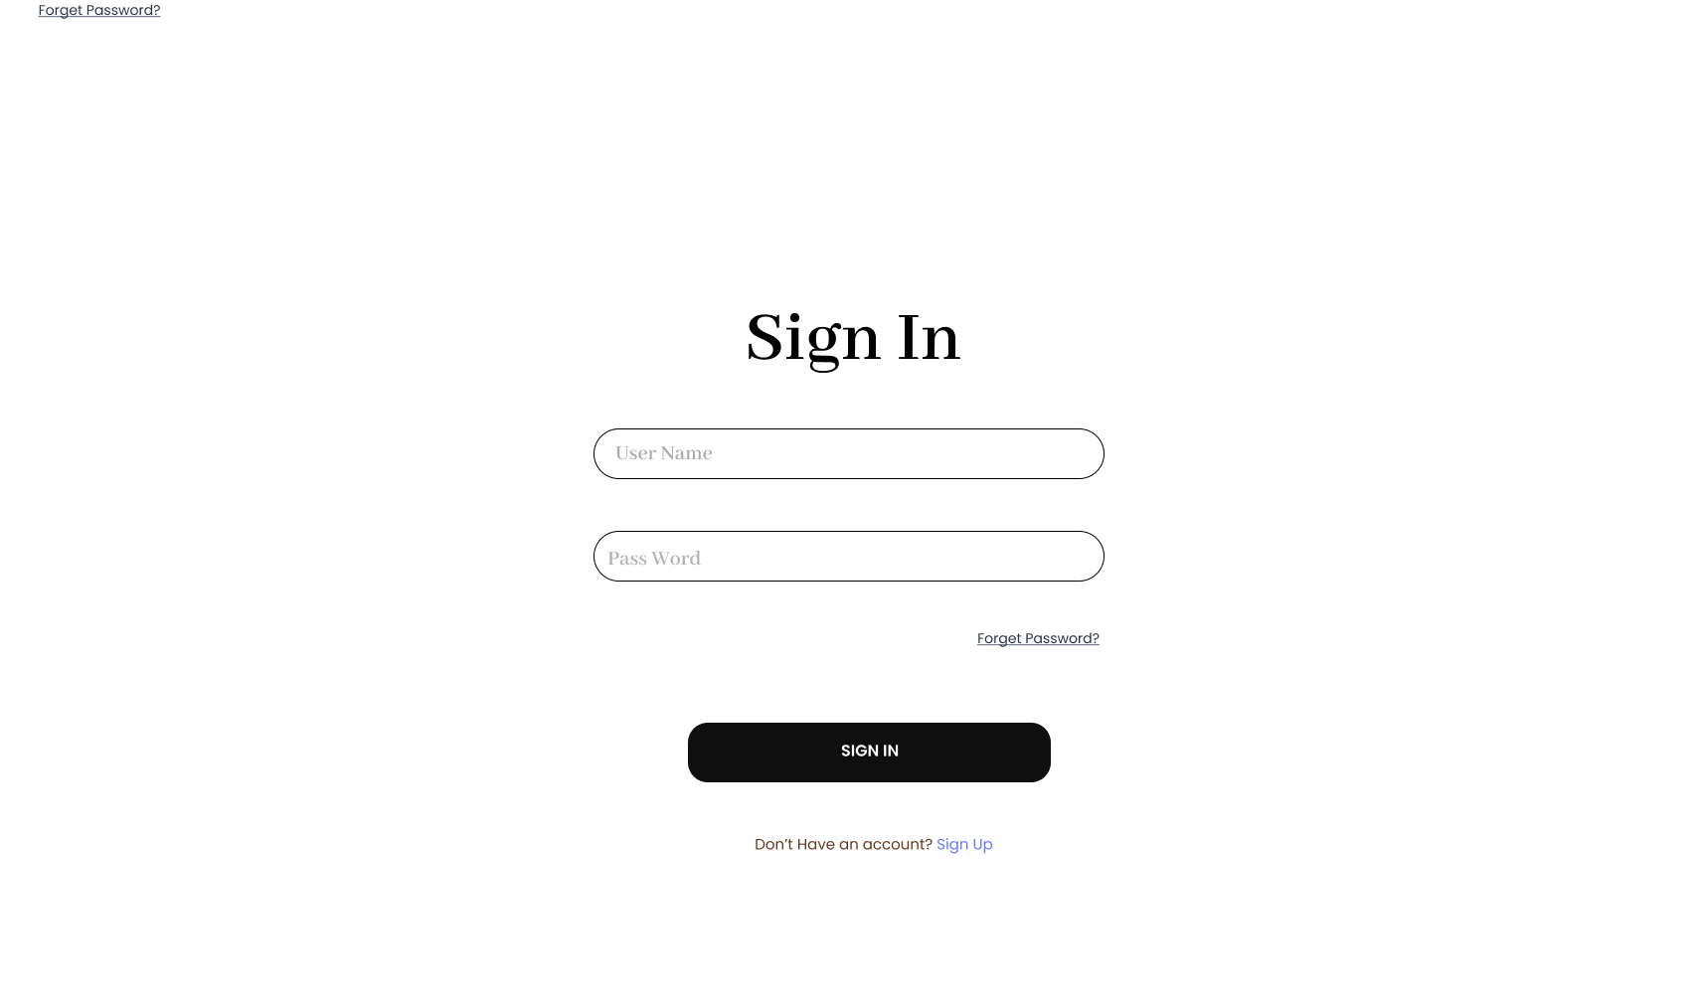
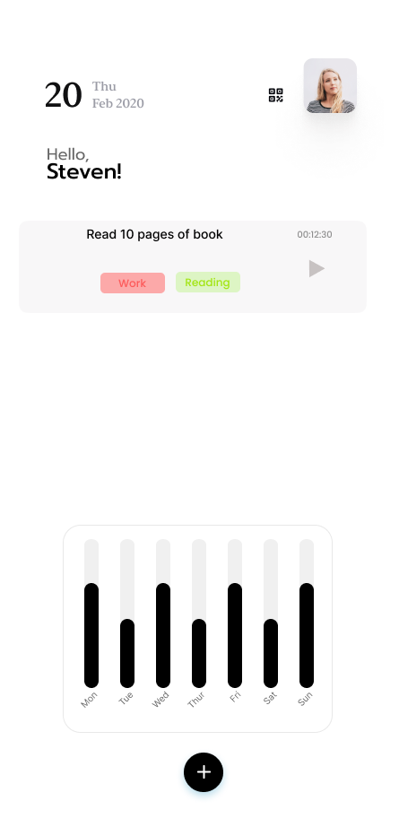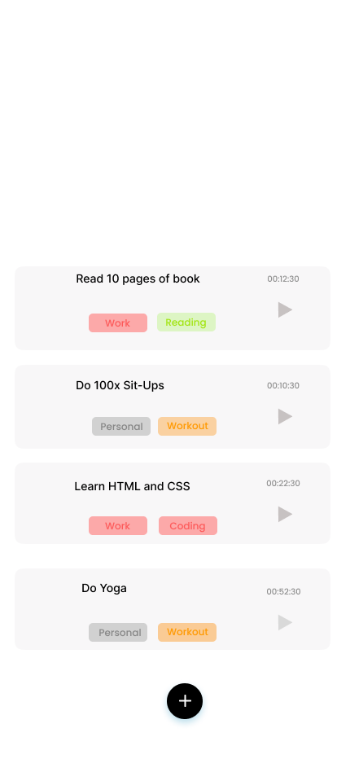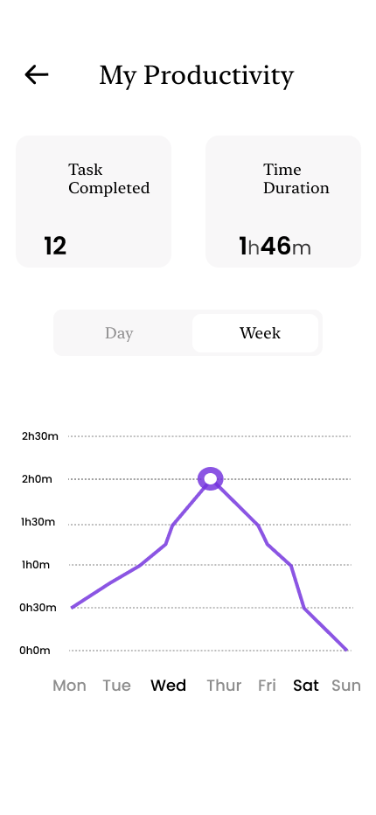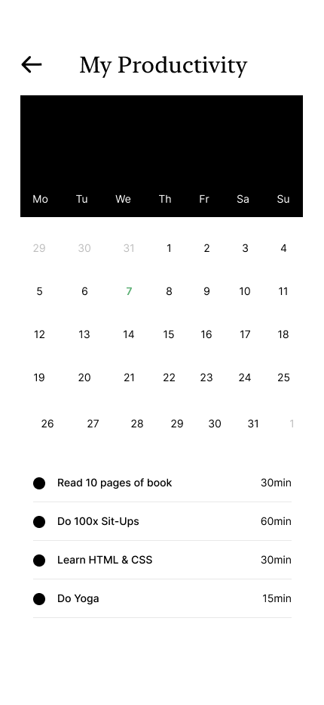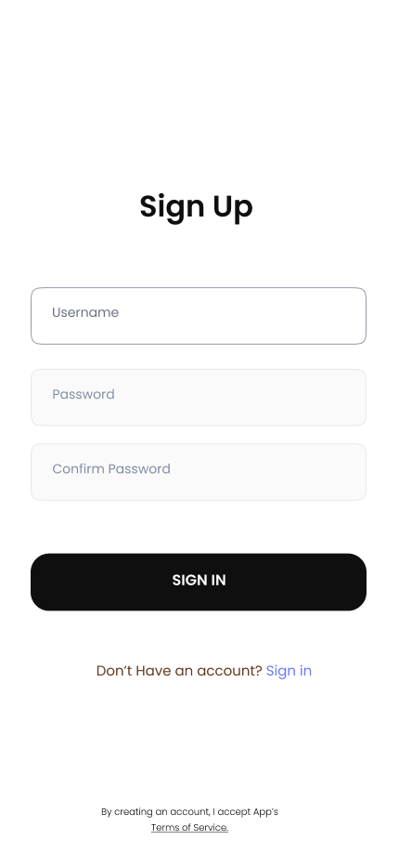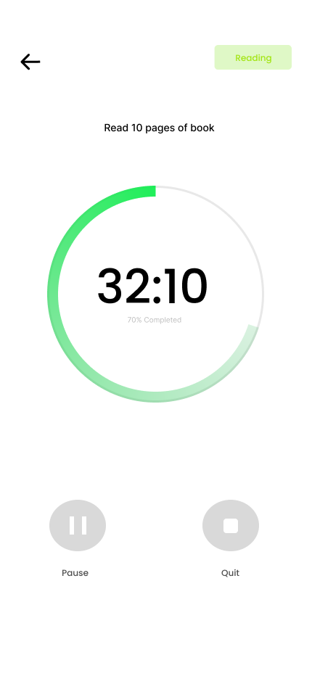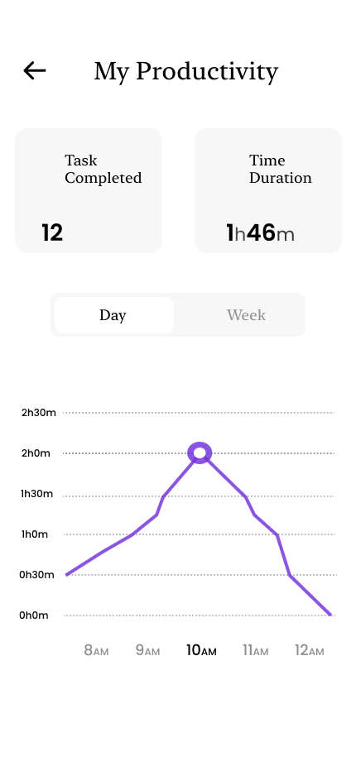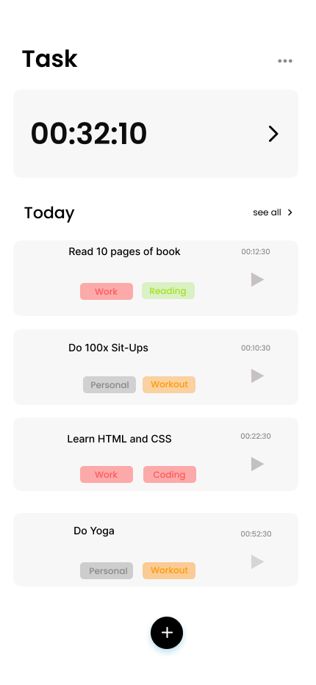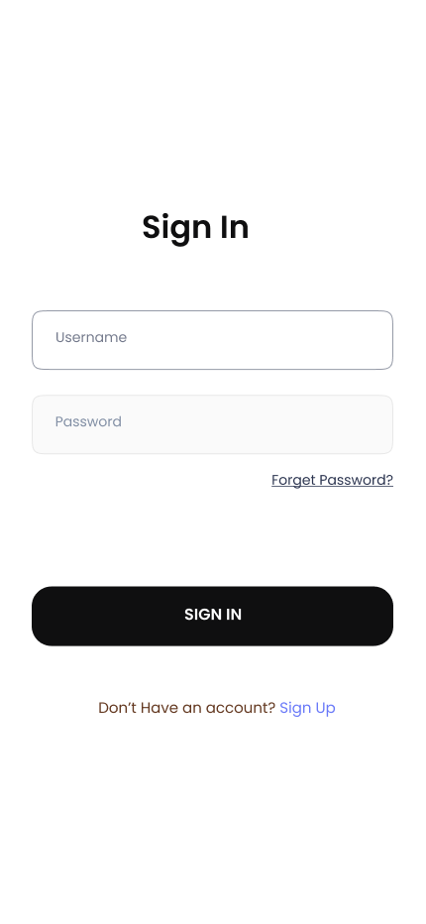

Sprint Review
The sprint review was held on 15/04/23 and attended by Vaishakh Nambiar, Utkarsh dev, Vignesh GS, Seethal Kavumnkal, Veeksha Suresh. Before approving or rejecting product backlog items as noted above, key decisions from the review were:
- The Application authentication was completed successfully in sprint 1. We were able to fetch data and display it in the dashboard.
- Login and Sign-up was done using JWT tokens and the data was pushed to Mongo DB schema using express and mongoose. The front-end is done using React.
- The current backlog of the project is to create a new task and set priority.

Sprint Retrospective
The team held a sprint retrospective on 16/04/23. It was attended by everyone. Key decisions were:
- The product backlog to be completed by end of April.
- Adding functionalities like productivity report, time tracker and calendar implementation in our next sprint.

